- made of ions
- many soluble in water but not in nonpolar liquid
- made of molecules
- poor electrical conductors
- Many soluble in nonpolar liquids but not in water
- Elements from opposite ends of the periodic table will form this kind of bond
- LARGE differences in electronegativity
- Elements are close together in electronegativity values
- CO₂
- H₂O
- NaCl
- C₆H₁₂O₆
- attraction between oppositely charged ions in a chemical compound
- These kinds of bonds occur mainly between a metallic and a non metallic atom.
- bonding between two non metallic atoms which is characterized by the sharing of pairs of electrons between atoms
- Chemical bonds
- Prefixes used when naming
- Carbon tetrachloride
- Binary compound name ends in –ide
- Lithium acetate
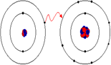
- 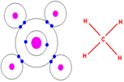
- Nonpolar
- Polar
- Involve electrons
- Involve nonmetals
- Involve metals
- Donating electrons to become a positive ion
- Cations
- Anions
- Representative particles are formula units (f.u.)
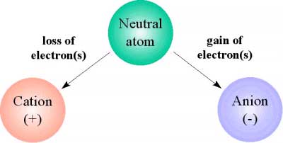
- Lewis dot diagrams show these with straight lines
- Lewis dot diagrams show these with an arrow moving an electron
- chemical substance consisting of two or more different chemically bonded chemical elements, with a fixed ratio determining the composition
- The flame test lab used compounds of this type
- one atom gains electrons to form an anion
- satisfy the octet rule
- electrons are shared equally
- H₂
- electrons are shared unequally
- dipole interactions

